Lab Exercise 28 – RPM-Based Upgrade and Rollback of MinIO

Lab Objective
- Verify existing MinIO installation
- Upgrade MinIO using RPM
- Validate service and data after upgrade
- Roll back MinIO to a previous version using RPM
- Verify rollback success

Prerequisites
- MinIO already installed using RPM
- Running MinIO as a systemd service
- Root or sudo access
- Data directory (example: /data/minio) already in use

Part 1: Verify Current MinIO Version
Step 1: Check installed MinIO version
minio --version
Example output:
minio version RELEASE.2024-10-13T13-34-11Z

Step 2: Check MinIO service status
sudo systemctl status minio

Step 3: Confirm RPM package details
rpm -qi minio

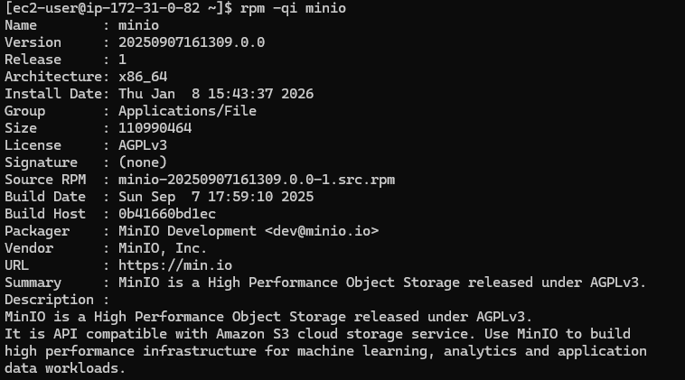
Part 2: Backup Configuration (Mandatory)
Step 4: Backup MinIO configuration
sudo cp /etc/default/minio /etc/default/minio.bak

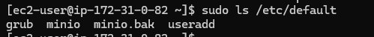

Step 5: Verify data directory (no backup needed)
ls -lh /data/minio

Note: MinIO upgrades do not modify data.

Part 3: Upgrade MinIO Using RPM
Step 6: Check system architecture
uname -m
- x86_64 → amd64
- aarch64 → arm64

Step 7: Download latest MinIO RPM
For x86_64
wget https://dl.min.io/server/minio/release/linux-amd64/minio.rpm

For ARM (Graviton)
wget https://dl.min.io/server/minio/release/linux-arm64/minio.rpm

Step 8: Stop MinIO service
sudo systemctl stop minio

Step 9: Upgrade MinIO RPM
sudo dnf install -y ./minio.rpm

RPM automatically replaces the old version.

Step 10: Start MinIO service
sudo systemctl start minio

Step 11: Verify upgraded version
minio --version

Step 12: Verify service health
sudo systemctl status minio

Part 5: Rollback MinIO Using RPM
Scenario
Upgrade caused issues → revert to previous MinIO version

Step 15: List installed MinIO versions
rpm -qa | grep minio

Step 16: Download specific older MinIO RPM
Example:
wget https://dl.min.io/server/minio/release/linux-amd64/archive/minio.RELEASE.2024-09-22T00-33-12Z.rpm
(Use correct architecture path)

Step 17: Stop MinIO
sudo systemctl stop minio

Step 18: Downgrade (rollback) MinIO
sudo rpm -Uvh --oldpackage minio.RELEASE.2024-09-22T00-33-12Z.rpm

Step 19: Start MinIO
sudo systemctl start minio

Step 20: Verify rollback version
minio --version

Part 6: Post-Rollback Validation
Step 21: Check service status
sudo systemctl status minio

Step 22: Verify data integrity
ls /data/minio

Step 23: Verify console access
http://<EC2-IP>:9001

